FH456-- How to setup Port Forwarding
Note: This article will guide you how to setup Port Forwarding and the steps as below.

Step 1: Connect your computer to the LAN port.Power on the FH456.
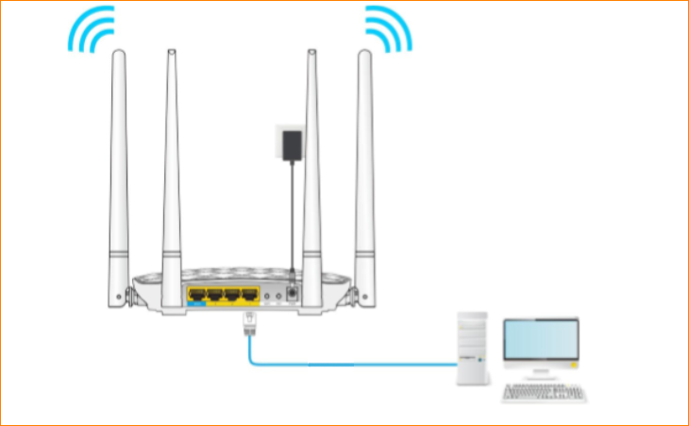
You can also use your smartphone to configure the router.
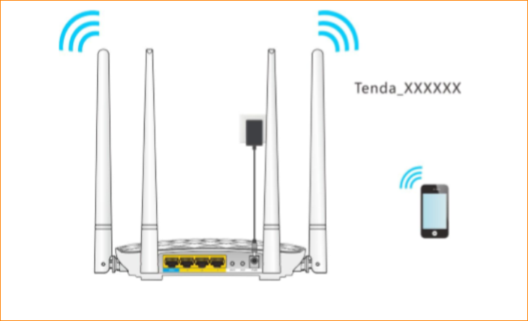
Step 2: Open a Web Browser -> Type http://tendawifi.com or 192.168.0.1 in the address bar -> Press Enter
Step3: tap “Advanced”-> “Static IP”, bind an fixed IP address with the MAC address of the mapping device. To avoid IP changing leading to the client fail connection.
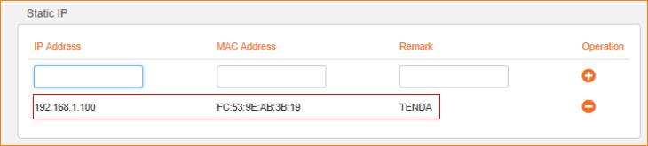
Step 4: Fill in IP address you bind, the port number of internal network port you filled in is opened by the mapped devices. The port number of exterior network port you filled in can be the same as internal network port, you can also fill in different port number on the exterior network port, then click the “+”, and then click "OK" button to save all settings.
